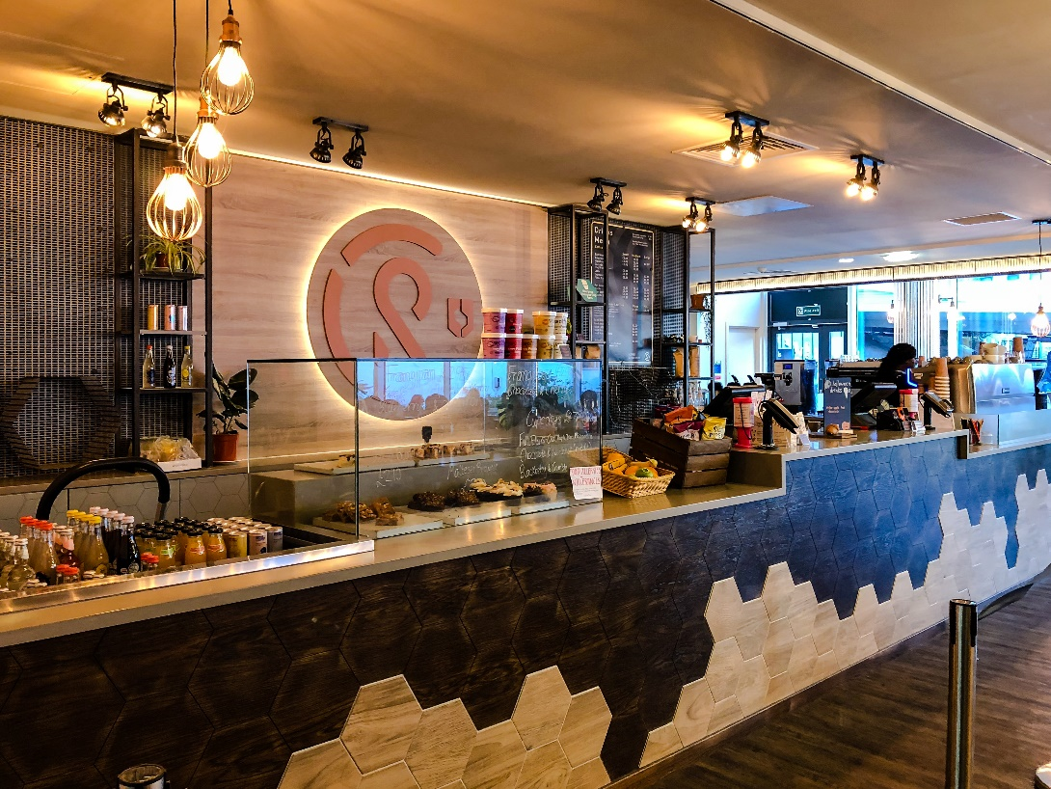

## Coffee Revolution

Sheffield Students' Unions own coffee house is not only one of the busiest cafes in Sheffield, it's also one of the best. With it's signature espresso blend, milk from a dairy up the road, and locally sourced cakes and sandwiches, it's a great place for breakfast, lunch, or a treat whenever you feel like one.More details: https://su.sheffield.ac.uk/eat-drink-shop/coffee-revolution（source: <https://su.sheffield.ac.uk/eat-drink-shop>）

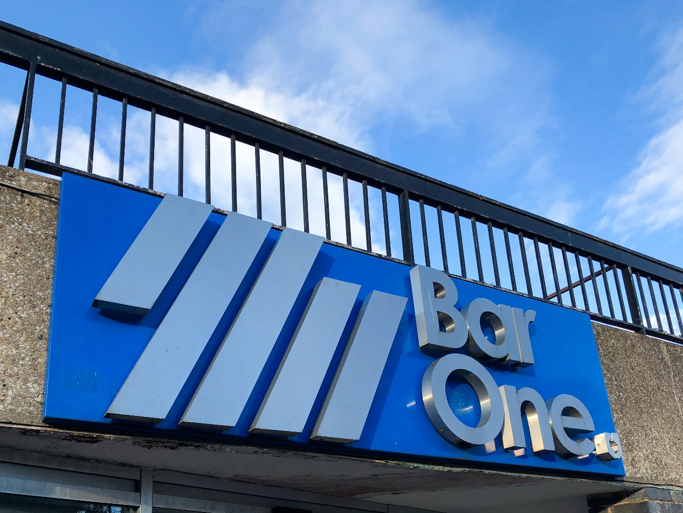

## Bar One

The legendary home from home for Sheffield Students is a firm favourite for all sorts of fun, seven days a week. Bar One is famous for towering tasty burgers, regular quizzes, all the best sport and a whole lot of friendly staff! More details: https://su.sheffield.ac.uk/eat-drink-shop/bar-one （source: <https://su.sheffield.ac.uk/eat-drink-shop>）

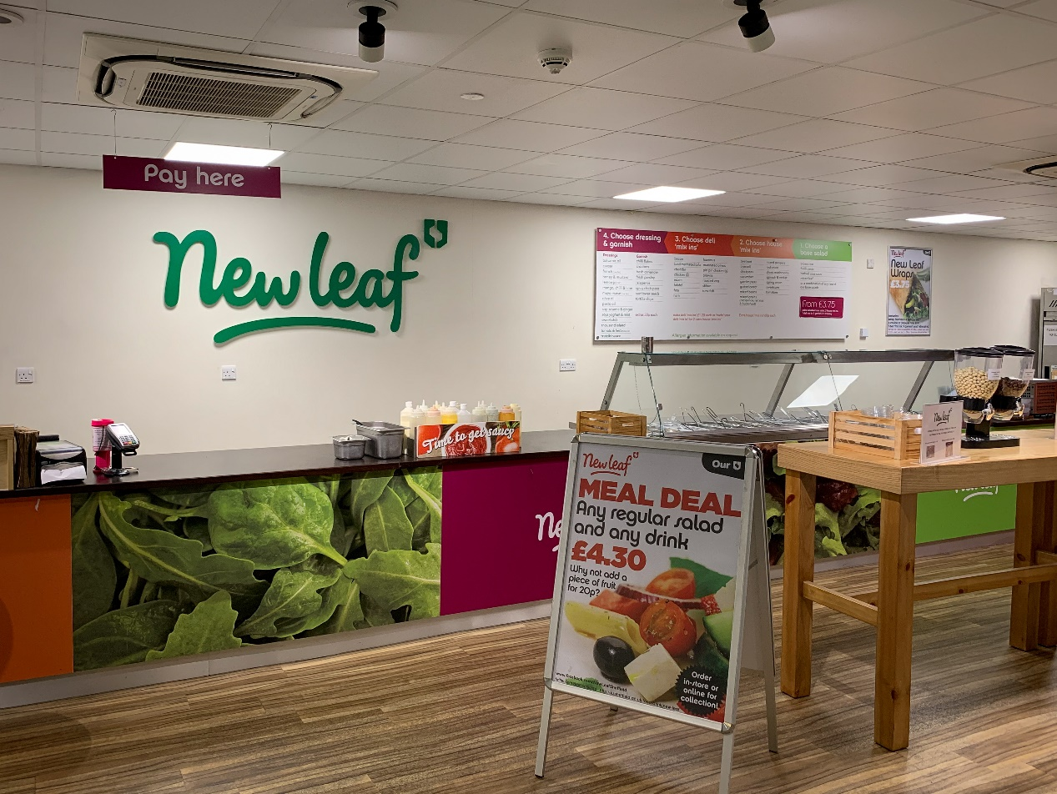

## New Leaf

Sheffield Students' Union's innovative Salad Bar. New Leaf was created to meet the demands of our members to have fast, fresh, and healthy food available to them throughout their University week.Come in and create the perfect take away salad or wrap for yourself. We have a wide selection of products and thousands of combinations to choose your favourite. More details: https://su.sheffield.ac.uk/eat-drink-shop/new-leaf（source: <https://su.sheffield.ac.uk/eat-drink-shop>）

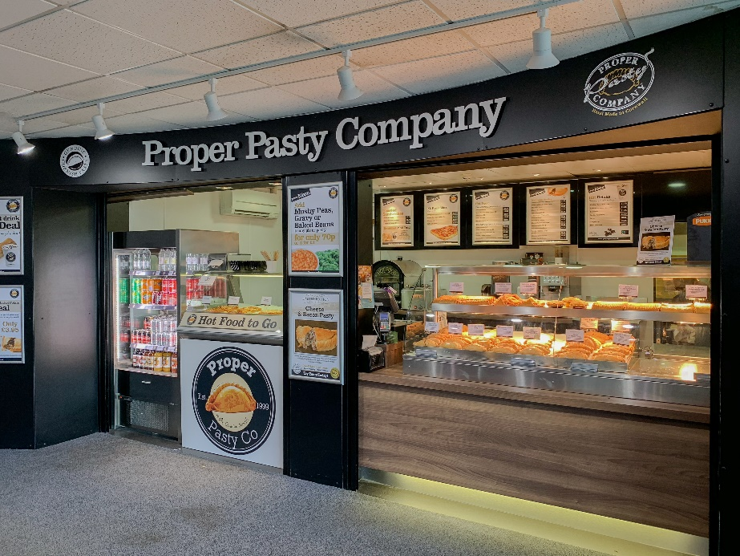

## Proper Pasty

Each and every Cornish Pasty which we bake has been lovingly created for you by hand. The hand layering process of the diced ingredients is true to the roots of the Cornish Pasty, this is something which we are very proud of! Rest assured a Proper Pasty is hand crimped and hand filled. More details: https://su.sheffield.ac.uk/eat-drink-shop/proper-pasty（source: <https://su.sheffield.ac.uk/eat-drink-shop>）

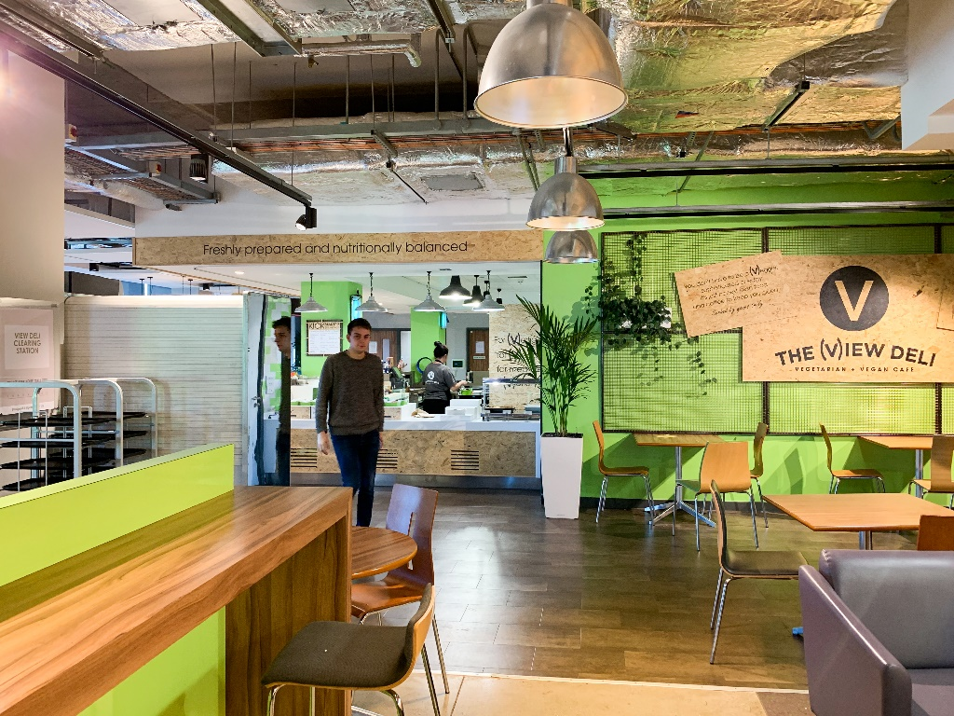

## The View Deli

Meat is off the menu at The View Deli. Against the fantastic city backdrop, tuck into a host of freshly made vegetarian, vegan and gluten free treats and tasty lunches - don’t forget to take a look at the daily chalkboard menu and view our range of Coffee HoUSe hot and cold drinks.

More details: https://su.sheffield.ac.uk/eat-drink-shop/the-view-deli （source: <https://su.sheffield.ac.uk/eat-drink-shop>）

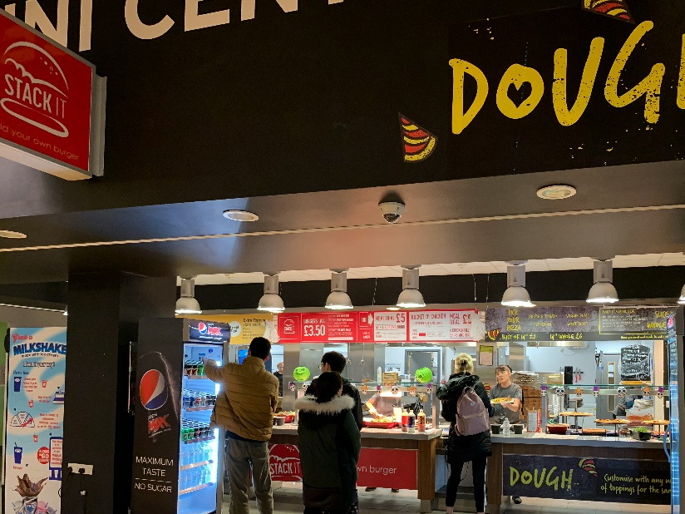

## Uni Central

Come and meet the team inside the Students’ Union preparing an array of exciting food from the Stack It burger, Dough pizza and Grill & Go wrap stations. More details: https://su.sheffield.ac.uk/eat-drink-shop/uni-central（source: <https://su.sheffield.ac.uk/eat-drink-shop>）

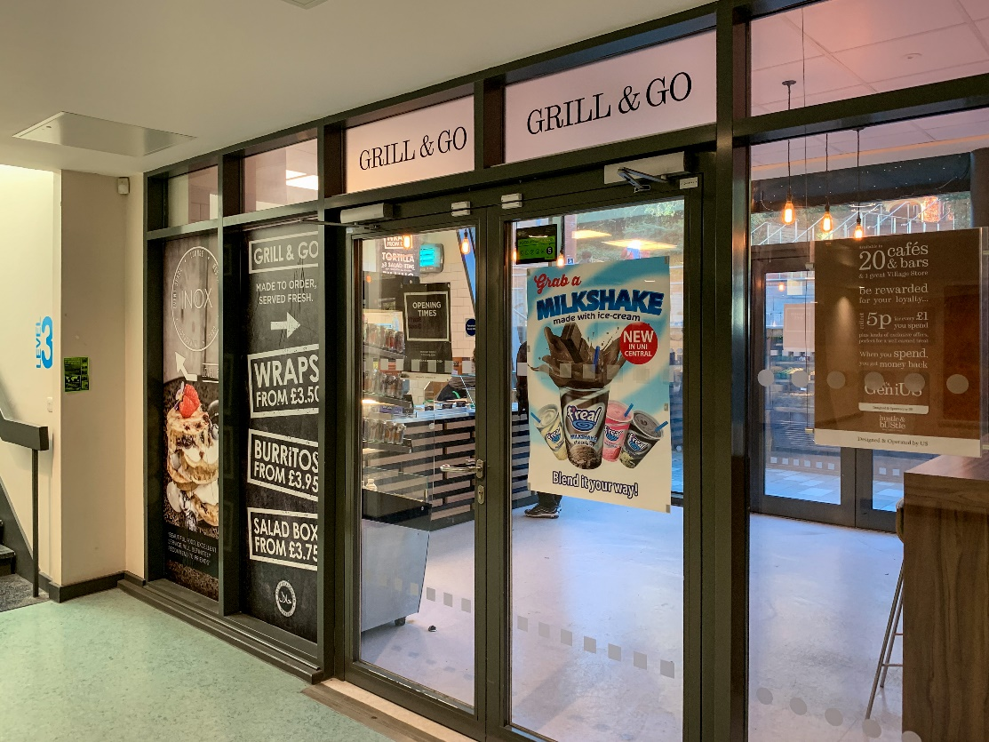

**Grill & Go**

A campus favourite. Come and try the burritos, hot wraps and salad boxes, cooked fresh and made to order. They are healthy and packed full of flavour – perfect for those on the go! More details: https://su.sheffield.ac.uk/eat-drink-shop/grill-go（source: <https://su.sheffield.ac.uk/eat-drink-shop>）

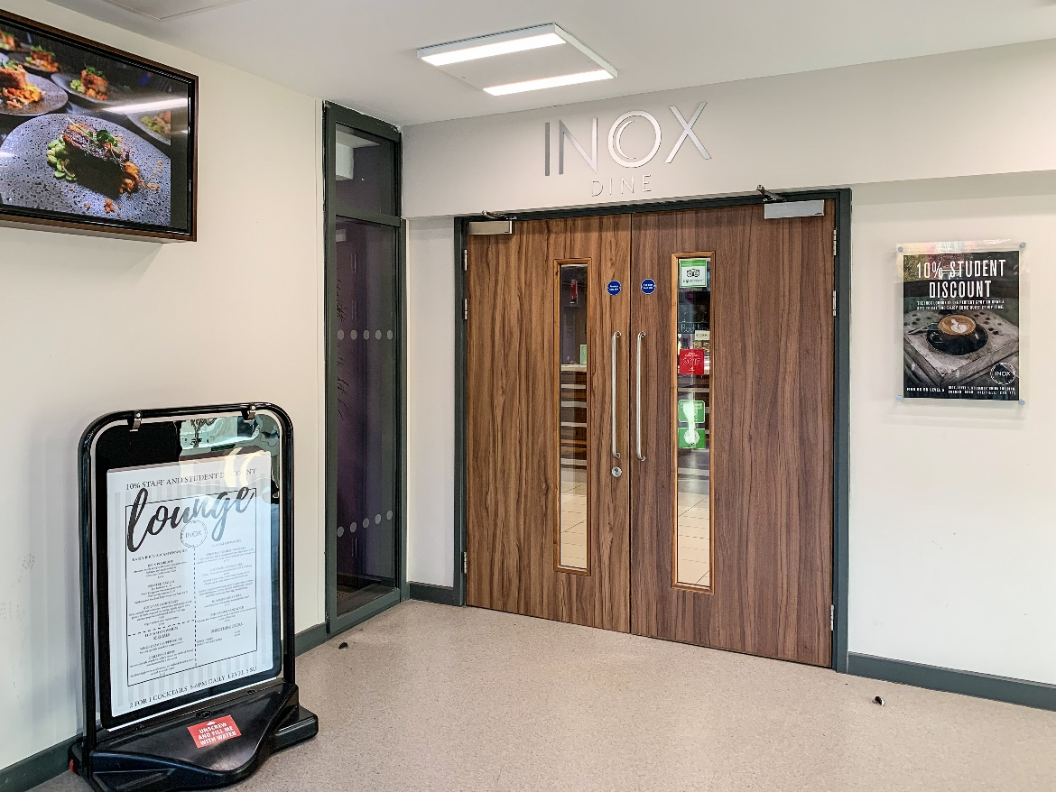

**INOX**

Conveniently located at the heart of the campus, Inox is a fresh thinking, stylish multi-functional lounge and social working space offering the very the best in drink and dining.More details: http://inoxdine.co.uk/ （source: <https://su.sheffield.ac.uk/eat-drink-shop>）

